Time : 30 mins

Aptitude Test:

Question : 1

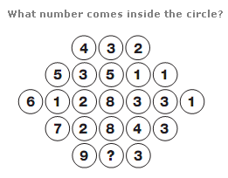

ANS :

Quesiton : 2

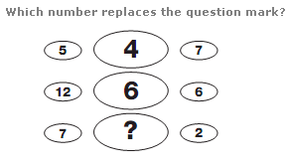

Ans :

Question : 3

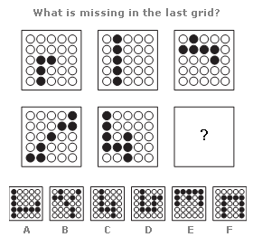

Ans :

Question 4:

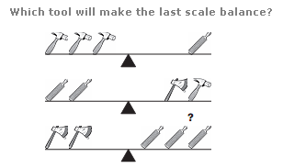

Ans : (hints : Axe or file or hammer)

**Question 5**:

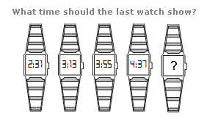

Ans :

Question 6:

Look at this series: 2, 1, (1/2), (1/4), ... What number should come next?

1. (1/3)
2. (1/8)
3. (2/8)
4. (1/16)

**Ans** :

**Question 7**:

Look at this series: 53, 53, 40, 40, 27, 27, ... What number should come next?

1. 12
2. 14
3. 27
4. 53

**Ans** :

**Question 8:**

Tanya is older than Eric. Cliff is older than Tanya. Eric is older than Cliff. If the first two statements are true, the third statement is

1. true
2. Flase
3. Uncertain

**Ans:**

**Question 9**:

A train running at the speed of 60 km/hr crosses a pole in 9 seconds. What is the length of the train?

1. 120
2. 180
3. 324
4. 150

**Ans** :

**Question 10**:

In a box, there are 8 red, 7 blue and 6 green balls. One ball is picked up randomly. What is the probability that it is neither red nor green?

1. (1/3)
2. (3/4)
3. (7/19)
4. (8/21)
5. (9/21)

**OOP Questions:**

**Question 1**: What is polymorphism?

**Question 2**: State the differences between tight coupling and loose coupling ?

**Question 3**: What is method overloading and over ridding ?

**Question 4**: What is encapsulation ?

**Question 5**: When observer pattern is used ? (Best answer is when necessary :P)